Pinni Venkata Abhiram

20BAI1132

CSE3002 – Internet and Web Programming

Lab – 8

Question – 1

Read the register number or branch name from the student and display the corresponding electives names in a table using DOM. (Minimum two electives names, Course codes for each program and implement it for two programmes) in the click event of the button.

Question – 2

Implement the code using HTML, JS Display the name of the faculty in the message box when the user clicks course code using DOM.

The above questions are related so we do them in a single HTML and JS file

HTML Code

<!DOCTYPE html>

<html lang="en">

<head>

    <meta charset="UTF-8">

    <meta http-equiv="X-UA-Compatible" content="IE=edge">

    <meta name="viewport" content="width=device-width, initial-scale=1.0">

    <title>DOM exercise</title>

</head>

<body style="padding: 20px; border: 2px solid; padding-top: 50px;">

    <form name = "f1" style="font-size: 20px; padding-left: 20px;">

        Enter registration number :

        <input type="text" name = "t2">

        <input type="button" class="submit1" value="Submit your value">

    </form>

    <br><br>

    <div class="disp" style="font-size: 20px; padding-left: 20px;"></div><br><br>

    <h2 style="padding-left: 20px;">Message box</h2>

    <div style="padding-left: 20px;">

        <input type="text" class="msg" value="" size="30" style="font-size:20px; padding-top: 5px; padding-bottom: 20px;"><br><br>

    </div>

    <script src="index.js"></script>

</body>

</html>

JS Code

document.querySelector('.submit1').addEventListener("click",function1);

let table = document.createElement('table');

let thead = document.createElement('thead');

let tbody = document.createElement('tbody');

function tablecreate()

{

    table.appendChild(thead);

    table.appendChild(tbody);

    table.classList.add("table1");

    document.querySelector('.disp').appendChild(table);

    table.classList.add("class1");

    let row_1 = document.createElement('tr');

    let heading_1 = document.createElement('th');

    heading_1.innerHTML = "Elective";

    let heading_2 = document.createElement('th');

    heading_2.innerHTML = "Full name of elective";

    table.cellPadding = "4px";

    table.cellSpacing = "4px";

    row_1.appendChild(heading_1);

    row_1.appendChild(heading_2);

    thead.appendChild(row_1);

}

function addbody(a,b)

{

    let row_2 = document.createElement('tr');

    let body1 = document.createElement('td');

    body1.innerHTML = a;

    let body2 = document.createElement('td');

    body2.innerHTML = b;

    row_2.appendChild(body1);

    row_2.appendChild(body2);

    tbody.appendChild(row_2);

}

function function1()

{

    var regno = document.f1.t2.value;

    if (regno.slice(2,5) === "BAI")

    {

        if (table.rows.length > 0)

        {

            for (var i = 0 ; i < 3 ;i++)

            {

                document.querySelector('.table1').deleteRow(0);

            }

        }

        tablecreate();

        addbody("CSE1014","Foundations of AI");

        addbody("CSE1015","Machine Learning Essentials");

        x = table.rows[1].cells[0].innerHTML;

        table.rows[1].cells[0].addEventListener("click",function(){

            document.querySelector('.msg').setAttribute("value","CSE1014 Faculty : Priyadarshini J");

        });

        table.rows[2].cells[0].addEventListener("click",function(){

            document.querySelector('.msg').setAttribute("value","CSE1015 Faculty : Rajalakshmi R");

        });

    }

    if (regno.slice(2,5) === "BPS")

    {

        if (table.rows.length > 0)

        {

            for (var i = 0 ; i < 3 ;i++)

            {

                document.querySelector('.table1').deleteRow(0);

            }

        }

        tablecreate();

        addbody("CSE1020","Cipher Analysis");

        addbody("CSE3000","Web Mining");

        table.rows[1].cells[0].addEventListener("click",function(){

            document.querySelector('.msg').setAttribute("value","CSE1020 Faculty : Premlatha M");

        });

        table.rows[2].cells[0].addEventListener("click",function(){

            document.querySelector('.msg').setAttribute("value","CSE3000 Faculty : Suganya G");

        });

    }

}

Output

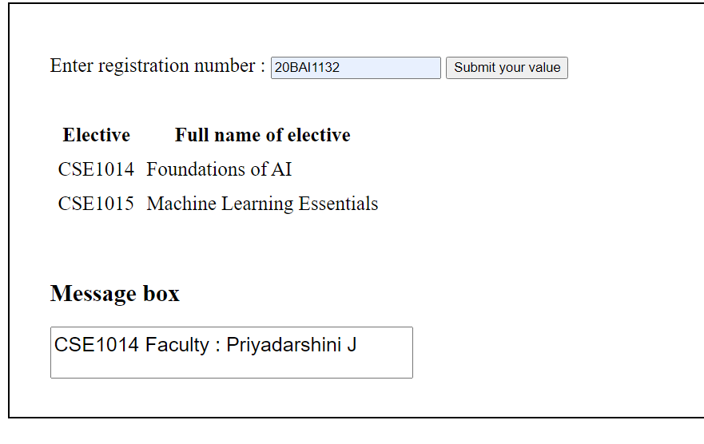

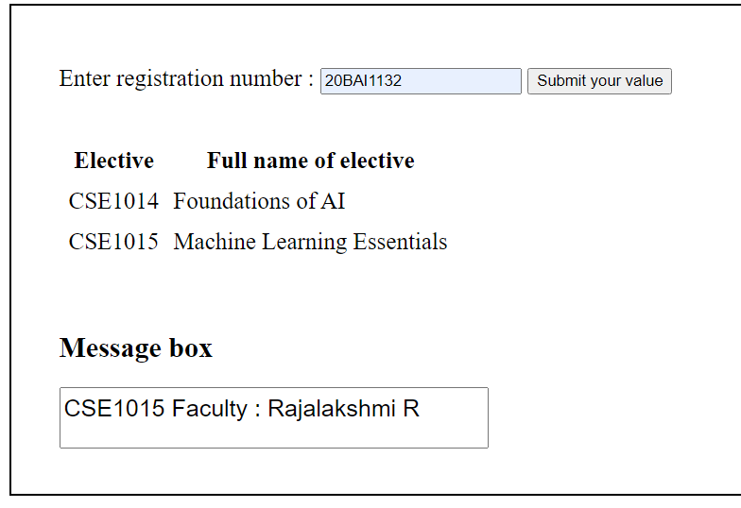

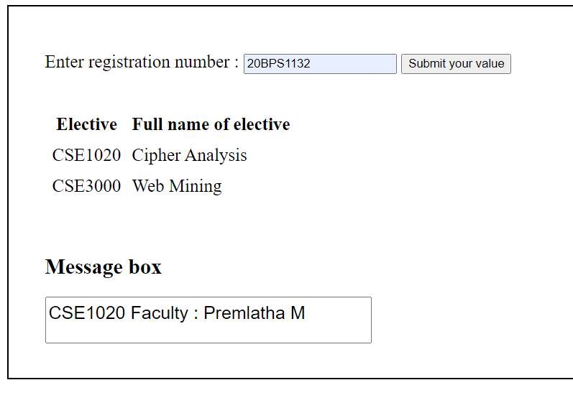

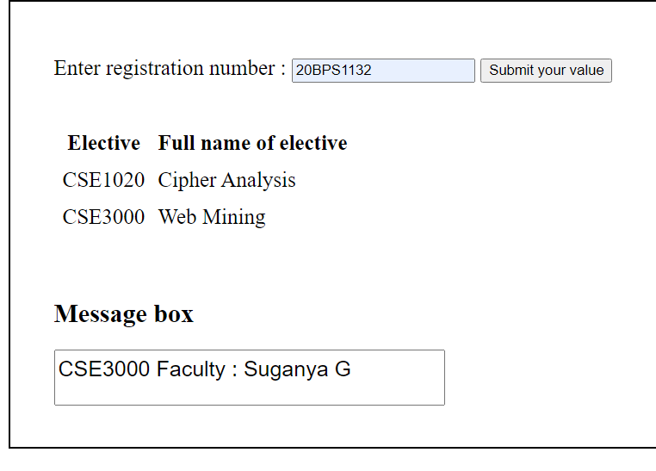

Thank you ma’am

Pinni Venkata Abhiram

20BAI1132